**Ridge Regression**

**TOTAL POINTS 2**

1.Question 1

consider the three polynomial regression models, select the model that would most benefit from Ridge Regression:

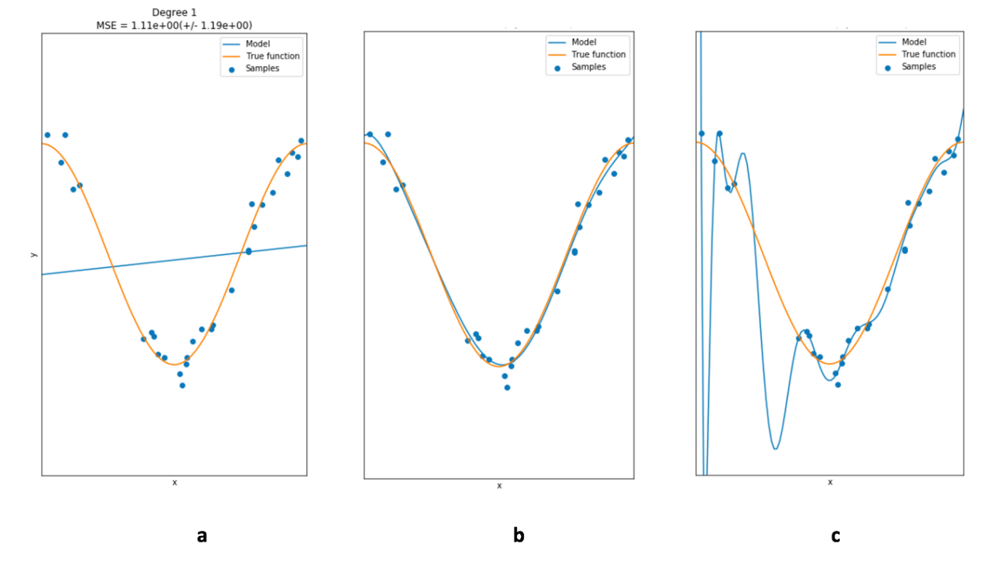



a



b



c

1 point

1.Question 1

consider the three polynomial regression models, select the model that would most benefit from Ridge Regression:



**Correct C**